Functional Requirements Document

Raid Static Manager

THM

Han Gao 200354969

|  |  |  |  |
| --- | --- | --- | --- |
| **Version** | **Description of Change** | **Author** | **Date** |
| 1.0 | Raid Static Manger | Han Gao | Oct |
|  |  |  |  |

# CONTENTS

1. INTRODUCTION 4
   1. Purpose 4
   2. Scope 4
   3. Background 4
   4. Assumptions and Constraints 4
   5. Document Overview 5
2. METHODOLOGY 5
3. FUNCTIONAL REQUIREMENTS 5
   1. Context 5
   2. User Requirements 6
   3. Functional Requirements 6
4. OTHER REQUIREMENTS 7
   1. Interface Requirements 7
   2. Data Conversion Requirements 7
   3. Hardware/Software Requirements 8
   4. Operational Requirements 8

APPENDIX A - GLOSSARY 12

# INTRODUCTION

# Purpose

This Web application is focus on help team leaders to manage their team more effective.

# Scope

A web-based management software that can improve efficiency on team(static) management in game for team leaders. It can help team leader in game to deal with their daily problems that happen in teams to avoid some unnecessary arguments, such as make attendance and reward distribution and recording the battle situation for each fight(raid) .

# Background

Every time when team leaders in game that want to corresponding their teams, they will need to use as least one social media software, and at least one document software such as: Excel. They need to go between some of different software to manage their teams. Now, they only use Raid Static Manager to do all the team manage work

# Assumptions and Constraints

# Assumptions

Every team leader who has a team in the game can register an account on the website to upload their static and use it to manage their team

# Constraints

Constraints are boundary conditions on how the system must be designed and constructed. Examples include: legal requirements, technical standards, strategic decisions.

* It is must be finished before project day on Saturday April 4,2020
* It can’t be too complicated based on one-person project

## Document Overview

This documents contains what is this project, what are the target costumers,how it works, what type of methodology is using and what are the functionalities.

**2.METHODOLOGY**

The methodology of the project is waterfall, which is directly go through step by step to develop the project. These steps are : requirement gathering & analysis, system design, implementation, testing, deployment of system, maintenance.

**3.FUNCTIONAL REQUIREMENTS**

# 3.1Context

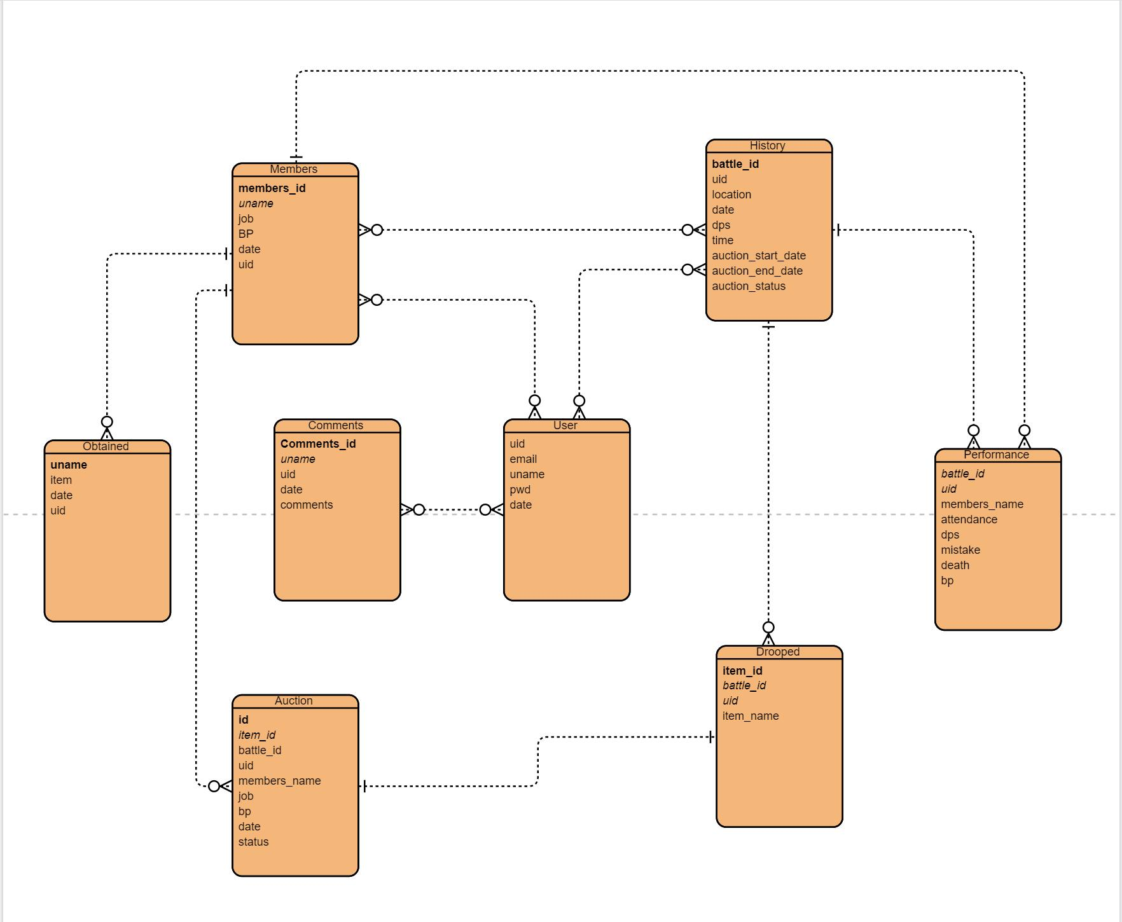

# User Requirements

1. Account permission
2. Add/Remove members
3. Make attendance
4. Team efforts calculation
5. Record fighting situations
6. Items distribution situations recording
7. Leave comments

# Functional Requirements

# The register system should allow users to register a new account.

# The background color for all windows on the website should be the linen.

# The login system automatically validates the pair of username and password.

# The software system should automatically display the data that relate to the current the user.

# The comments system should allow users to leave comments.

# The battle record system should allow uses to record their battle data in the database and display on the particular page.

# The members system should allow users to change the members list and coordinate the whole system.

# The auction system should allow users to make an auction for the item and automatically filter the highest bidder and assign item to the bidder.

# OTHER REQUIREMENTS

# 4.1Interface Requirements

# 4.1.1Hardware Interfaces

Any pc with screen width larger than 13.

# Software Interfaces

Details see in lo-fi prototype

# Communications Interfaces

Details see in lo-fi prototype

# Security and Privacy

Consequences of the following breaches of security in the subject application:

* 1. Loss or corruption of data
  2. Disclosure of secrets or sensitive information
  3. Disclosure of privileged/privacy information about individuals
  4. Corruption of software or introduction of malware, such as viruse.

# System Availability

The whole system is available for 24/7

# Capacity

2GB

# Data Retention

As long as a new edition of the game has been updated.

# Error Handling

Database injection

# Validation Rules

Validate the wrong input

# Conventions/Standards

Windows

# APPENDIX A - GLOSSARY

[Define terms, acronyms, and abbreviations used in the FRD.]